Name : T.SAVIN KUMAR

ROLL NO : 2403a51045

BATCH NO : 02

1.Create a Python function that converts an amount from one currency to another using exchange rates stored in a dictionary. Use GitHub Copilot along with VS Code. Use Few shot prompting.

PROMPT :

write a Python function that reads input from the user and converts an amount from one currency to another using exchange

rates stored in a dictionary.

#Example 1 : 1USD converts to 86.79 Indian rupees

#Example 2 : 1 Pound converts into 118.63 Indian Rupees .

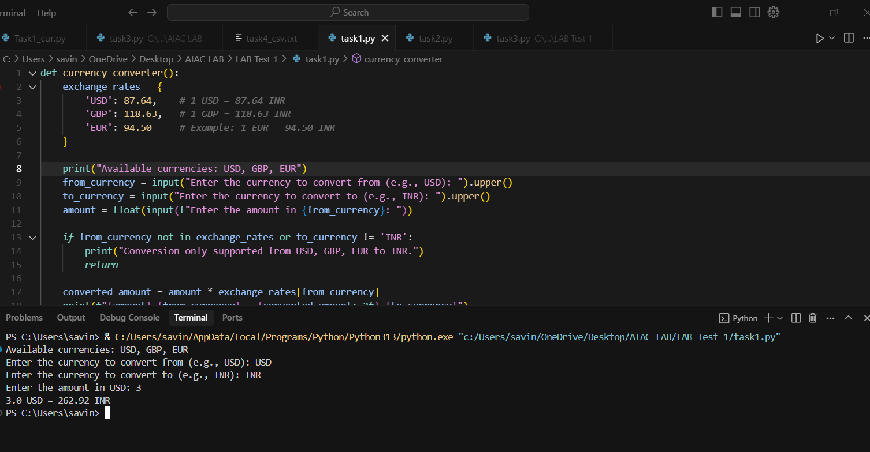

2.Write a Python program to extract all email addresses from a block of text using regular expressions. GitHub Copilot along with VS Code. Use zero shot prompting.

PROMPT : Write a Python program to extract all email addresses from a block of text using regular

expressions.

3.Given a list of movies with their genres, Write a Python function that recommends movies based on a user’s preferred genre. Use the Cursor AI tool. Use few shot prompting.

PROMPT :

Write a Python function that takes a list of movies with their genres from the user and recommends movies based on a user’s preferred genre.

#Example 1 : preferred genre is Avengers recommend Marvel movies

#Example 2 : Preferred genre is Dhruva recommend Action and thriller Movies

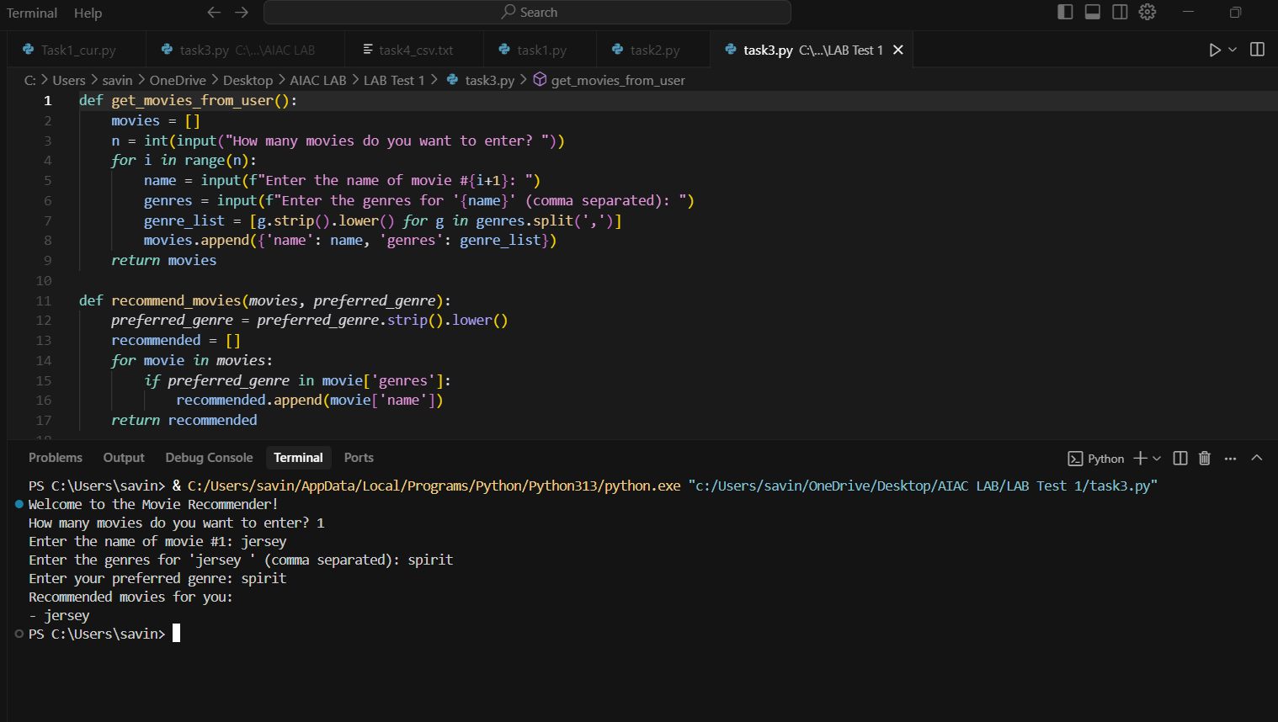

1. Write Python code that reads a CSV file containing student names and marks in 3 subjects.  
   Calculate the total and average marks for each student. Use the Cursor AI tool.

Prompt :

Write Python code that reads a CSV file like name ,subject1,subject 2,subject3 take input from the file task4.csv file console containing student names and marks in 3 subjects.

take input from the user to Calculate the total and average marks for each student



